Sicily Escorted Small Group

by Train 2024

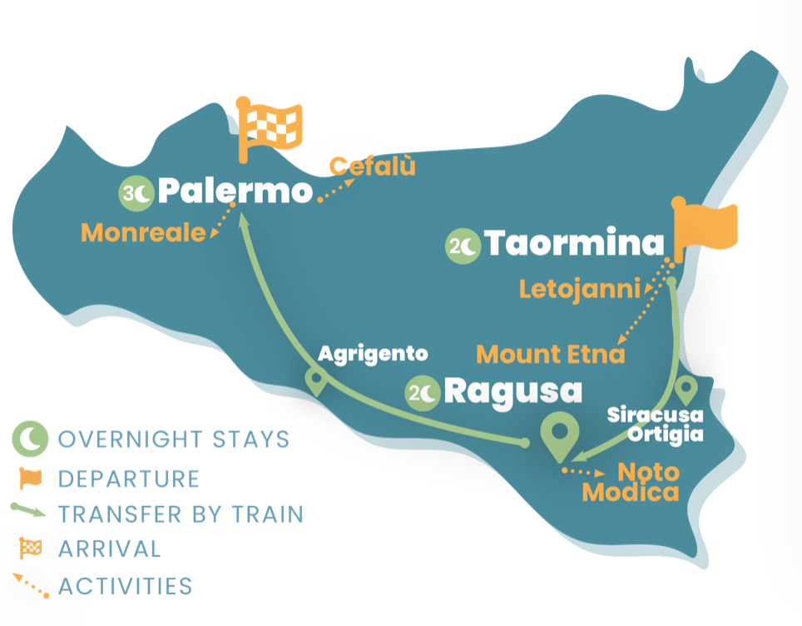
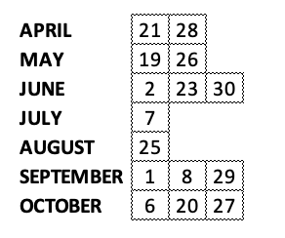

CALENDAR

Departure day is Sunday

8 NIGHTS – 9 DAYS

MAX GROUP SIZE: 20 pax

PHYSICAL LEVEL This trip can be enjoyed by just about anyone with a reasonable level of fitness. Average physical ability is required such as long walks of a few hours

You can check real time availability on our online PORTAL

WHAT’S INCLUDED

ACCOMODATION
7 nights in 4* hotel
- # 2 – Letojanni /Taormina: Hotel Albatross
- # 2 - Ragusa: Hotel Mediterraneo Palace
- # 3 – Palermo: Hotel NH Palermo

WORRY-FREE LUGGAGE
Thanks to our included porterage service at railway stations and/or our “luggage bus” (that delivers luggage from hotel to hotel), we make train travel stress-free.

GUIDE
Professional English speaking guide for the entire duration of the tour

TRANSPORT
Train transfers in First class
Luxury air-conditioned coach on route not covered by railway

MEAL
7 breakfasts
1 dinner
2 lunches

INCLUDED GROUP ACTIVITIES

TAORMINA / LETOJANNI: guided walking tour of Taormina & Mount Etna full day discovery by train

SIRACUSA: guided walking tour of Siracusa and Ortigia

RAGUSA: full day guided tour discovery of Sicilian Baroque: Noto and Modica

AGRIGENTO: guided tour of Temple’ Valley

PALERMO: guided walking tour of Palermo and Monreale & full day discovery tour of Cefalù by train.

CARBON OFFSET
We'll offset all the carbon emissions of your trip! We support international environmental projects oriented to carbon offset (according to Gold Standard, Verra standard or CDM standard) and plants native tree species across Italy.

BRIEF DESCRIPTION
Be prepared for an amazing journey: explore Taormina's historic sites and Mount Etna's breathtaking views. Enjoy food and wine tasting. Visit Syracuse and charming Ortigia. Marvel at Sicilian Baroque in Ragusa, Modica, and Noto. Explore Agrigento's Temples' Valley. Conclude in Palermo with Teatro Massimo and Monreale Cathedral. Experience Cefalù's picturesque charm.

INTRO - LONG DESCRIPTION
Here with Meet and Greet Italy, embark on an enchanting journey through Sicily. Start in Taormina, explore its sites and marvel at Mount Etna, Europe’s most active volcano. Traverse scenic routes aboard the Circumetnea train. Enjoy food and wine tasting at a local winery. Take a scenic train to Syracuse, known for its rich history. Explore the Archaeological Park and visit Ortigia’s charming streets and cathedral. Explore the cities of Ragusa, Modica, and Noto, renowned for Sicilian Baroque. Marvel at sumptuous palaces and ornate balconies. Visit Agrigento’s Temples’ Valley, a UNESCO site. Discover well-preserved ancient temples. Conclude in Palermo, with Teatro Massimo and Monreale Cathedral. Then, enjoy a day in picturesque Cefalù

ITINERARY
DAY 1 - TAORMINA
Upon arrival, make your way to your hotel in Letojanni, check-in and take your time to settle. In the afternoon meet your group and the tour leader. After an introductive briefing, reach Taormina and enjoy a guided walking tour of one of the most popular tourist destinations in Sicily. Admire its natural terrace
overlooking the sea dominated by the majestic volcano Mount Etna and visit the Greek-Romans Theater. Back to your hotel partake a welcome dinner.

DAY 2 – MOUNT ETNA
Today you will discover the Mt. Etna, the highest peak of Sicily and the most active volcano in Europe. After breakfast walk along the beach to Letojanni train station and reach the village of Giarre where you’re going to get on the Circumetnea train an historic railway inaugurated in 1898 which travels around the volcano passing through many villages, offering to its travelers’ picturesque glimpses of this unique view. The excursion will continue by bus to reach “Silvestri Craters” (about 1.900 mt). Enjoy food and wine tasting in a local winery and have the option to reach higher peaks by jeep. Return to hotel in Letojanni.

DAY 3 – SIRACUSA & ORTIGIA
Today you will admire the coast and the sea from your train window travelling from Taormina to Syracuse, one of the most interesting sites on the island. A guide will lead you to the discovery of the Archaeological Park, famous for its Roman amphitheater, the Greek theater, and the ear of Dionysus. Continue your visit by going to the island of Ortigia, the oldest part of the city, characteristic for its narrow alleys, for its sea views and for the wonderful square with its splendid cathedral. In the afternoon continue the journey by bus and reach your next destination, Ragusa.
DAY 4 – SICILIAN BAROQUE
A full day to discover the less known part of Sicily, dominated by the sumptuous and majestic Baroque style of the buildings, characterized by the numerous UNESCO sites, also known for the television series of “Il Commissario Montalbano”. Start your visit from the historic center of the city of Ragusa, “Ibla”, the aristocratic city of Val di Noto, characterized by the numerous baroque churches and palaces, as well as by the characteristic domes that dominate the city. Continue to Modica, a UNESCO World Heritage city especially known for its chocolate as well as for its wonderful buildings. Last stop will be Noto, the capital of late Sicilian Baroque Cross the famous Arco, stroll in the center admiring the wonderful aristocratic palaces with the famous decorated balconies, the sumptuous churches full of decorations, the cathedral with its staircase and the city theater, all built in Baroque style. Return to the hotel in Ragusa for overnight.

DAY 5 – AGRIGENTO
After breakfast departure by bus for Agrigento. Arriving in Agrigento enjoy a lunch overlooking the Temple Valley. After lunch, meet the guide who will reveal all the secrets of the Temples’ Valley, including the Temple of Juno, the Temple of Concorde (one of the best preserved Doric temples in the whole Greek world), the Temple of Hercules, the Temple of Castor and Pollux. At the end of the visit, reach Agrigento Centrale Train Station and embark on an extraordinary train journey through the Sicilian countryside to reach Palermo. Upon arrival in Palermo transfer to the hotel and check in.

DAY 6 – PALERMO & MONREALE
Full day dedicated to the discovery of Palermo: in the morning a walking tour of the city center, starting from Teatro Massimo continue the walk through the famous “u Capo” local market and taste some Sicilian specialties as Arancina or drink the famous “AUTISTA” an “explosive” lemonade. Continue to the Cathedral and walk to “I Quattro canti”. After some free time for lunch take the local bus to Monreale, a lovely town on the slopes of Monte Caputo overlooking Palermo. Walk with your guide to Monreale Cathedral, considered one of the finest Norman constructions in the world.

DAY 7 – CEFALU’
Today, with your tour leader, reach Cefalù by train in half an hour. Cefalù is a beautiful medieval fishers’ village, at the slopes of a promontory, hosts as well as Unesco World Heritage site, the Arabic-Norman Cathedral, that looks like a fortress. You will have the whole day at your disposal to relax on the beach, do shopping or hike up La Rocca! Back to Palermo by regional train, enjoy your last night in Sicily!

DAY 8 – END
After breakfast, our trip to the discovery of the Italian beauties comes to an end, hoping you always keep this unique experience in your heart. Feel free to book some extra nights in Sicily or a private transfer to Palermo’s airport.

