Venice, Florence and Rome

Escorted Small Group by Train 2024

VIDEO PRESENTATION

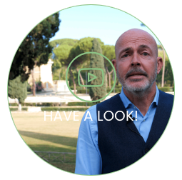
You can check real time availability on our online PORTAL

CALENDAR

Departure day is Sunday

SUN
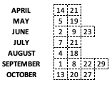

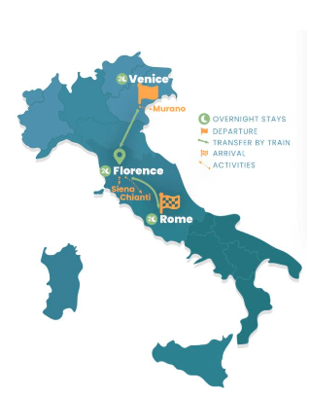

PHYSICAL LEVEL This trip can be enjoyed by just about anyone with a reasonable level of fitness. Average physical ability is required such as long walks of a few hours

MAX GROUP SIZE: 26 pax

7 NIGHTS – 8 DAYS

WHAT’S INCLUDED

WORRY-FREE LUGGAGE
Thanks to our included porterage service at railway stations and/or our “luggage bus” (that delivers luggage from hotel to hotel), we make train travel stress-free.

ACCOMODATION
7 nights in 4* hotel
- # 2 nights - Venice: NH Collection Murano Villa
- # 2 nights - Florence: Starhotel Michelangelo
- # 3 nights - Rome: Hotel Massimo d’Azeglio

The hotels listed are our main partner in each city; there may be changes which will be communicated by August 30

GUIDE
Professional English and French-speaking guide for the entire duration of the tour

MEAL
7 continental buffet breakfasts
1 dinner
1 food and wine testing
Welcome drinks and snacks on trains

TRANSPORT
High speed train transfer in First class
Vaporetto Pass 48H in Venice
Hop-on Hop-off 24H in Rome

CARBON OFFSET
We'll offset all the carbon emissions of your trip! We support international environmental projects oriented to carbon offset (according to Gold Standard, Verra standard or CDM standard) and plants native tree species across Italy.

INCLUDED GROUP ACTIVITIES
- VENICE: Murano Island walking tour with glass blowing visit // Highlights of Venice guided walking tour
- FLORENCE: Highlights of Florence guided walking tour // Siena discovery guided tour with food and wine tasting in a vineyard.
- ROME: Baroque Rome guided walking tour // Vatican Museum, Sistine Chapel, St. Peter Basilica // Hop on hop off 24

OPTIONAL

DINNER WITH FRIENDS
An occasion to stay together, have fun, and experience high-quality local food & wine in selected and typical restaurants. We want you to eat as an Italian, not as a tourist!
- Venice: Cicchetti & Polenta dinner
- Florence: Tuscan dinner with Fiorentina T-Bone steak
- Rome: Pasta (Cacio & Pepe, Matriciana) dinner

BRIEF DESCRIPTION
Enjoy an amazing journey: Venice, Florence, Rome. Get ready to explore some of the world’s most beautiful cities, see artisans on Murano Island, walk through Baroque Rome, and enjoy typical food and wine tastings in Chianti.

INTRO - LONG DESCRIPTION
Start your journey in one of the world’s most beautiful cities: Venice. Here you will spend two nights and visit the main historical sites and taste plenty of local food, plus an incredible experience on Murano Island, where artisans will show you the art of glass blowing. Head to the center of the country to visit the most important Italian art cities: Florence and Rome. You will spend two nights in each city visiting the main historical sites, including Piazza della Signoria, Brunelleschi’s Dome, Uffizi courtyard in Florence, and Trevi fountain, Vatican Museum, Sistine Chapel, St. Peter Basilica in Rome. Plus, on your second day in Tuscany you will visit Siena and enjoy a food and wine experience in one of Chianti’s vineyards.

ITINERARY
DAY 1 - VENICE
Upon arrival, make your way to your hotel and take your time to settle. In the afternoon meet your group, enjoy a welcome drink and then follow your tour leader who will let you discover the ancient and precious glass-blowing art in a traditional “furnace”. Return to your hotel and partake in a welcome dinner.

DAY 2 - VENICE
Today explore the floating City! Taking advantage of the Vaporetto Pass, move freely across the Historical center of Venice. Your guide will take you through narrow alleys, canals and small bridges to discover the main attraction, witnessing the mighty power of the city across the centuries. You’ll see the Rialto Bridge, Piazza S. Marco with its Basilica, the Doge’s Palace, and the Bridge of Sighs, that leads to the prisons. Time at leisure to stroll on your own and buy local glass-made souvenirs.

DAY 3 - VENICE TO FLORENCE
In the morning, take a high-speed train that will take you to Florence in two hours. Once there, start our guided tour on foot throughout the Florentine streets, admiring the beauty of the Uffizi building with the Vasari Corridor, and the monumental group of the Duomo, including the stunning Cathedral of Santa Maria del Fiore, the baptistery, and the Giotto’s belltower famous for its bronze “Gate of Paradise”.

DAY 4 - FLORENCE
Enjoy the morning at leisure, and in the early afternoon join a "Siena and Chianti Countryside" tour to experience firsthand some of Tuscany's most breathtaking towns, where amazing views are around every corner. You will reach Siena by train to discover the treasures of one of the most beautiful cities in the world and immerse yourself in its art, culture, and traditions as the horse race the Palio, which takes place twice a year. You will explore the best that Siena has to offer, our guide will accompany you along the ancient streets of Siena through the most beautiful sites. Continue towards a traditional farm and winery where we will learn about the winemaking process from grape to glass. Then enjoy a food and wine tasting session of Chianti wines as well as local products. Finally, sit back and relax on the return journey to Florence by train.

DAY 5 - FLORENCE TO ROME
After breakfast, take a high-speed train to arrive in Rome. In the afternoon meet again for a guided stroll throughout the alleys of the baroque Rome, where you can admire the most representative sites such as the magical Piazza Navona and the famous Pantheon. You will even have the possibility to make a wish, throwing a coin into the legendary Fontana di Trevi. The rest of the evening will be free. Overnight in the hotel.

DAY 6 - ROME
This morning take advantage of the Hop-on Hop-off bus to get a panoramic tour of the "eternal city" and reach the Vatican Museum. With the "skip-the-line", you will have direct access to the Sistine Chapel and to San Peter's Basilica to visit the breathtaking masterpieces that you will find inside, as well as a great variety of galleries, with ancient sculptures, tapestry, middle-age maps, paintings, and stunning relics. You will admire the Pietà di Michelangelo and the incredible altar in bronze.

DAY 7 - ROME
The entire day at your leisure or you may choose from optional tours such as Colosseum and Ancient Rome tour, Borghese Gallery tour if you prefer to learn more about local art and history, or maybe a fun Pizza Making Cooking Class to learn the secrets of the most famous Italian dish.

DAY 8 - ROME
After breakfast, our trip to the discovery of the Italian beauties comes to an end, hoping you always keep this unique experience in your heart. Feel free to book some extra nights in Rome or a private transfer to Rome’s railway station or airport. Arrivederci!

