Northern lakes: Stresa, Como, Verona and Venice

Escorted Small Group by Train 2024

VIDEO PRESENTATION

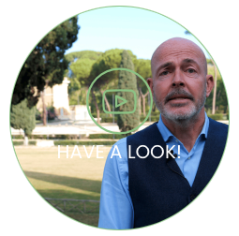

CALENDAR

Departure day is Saturday

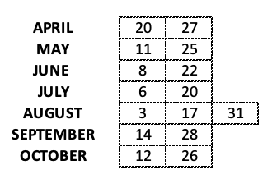

8 NIGHTS – 9 DAYS

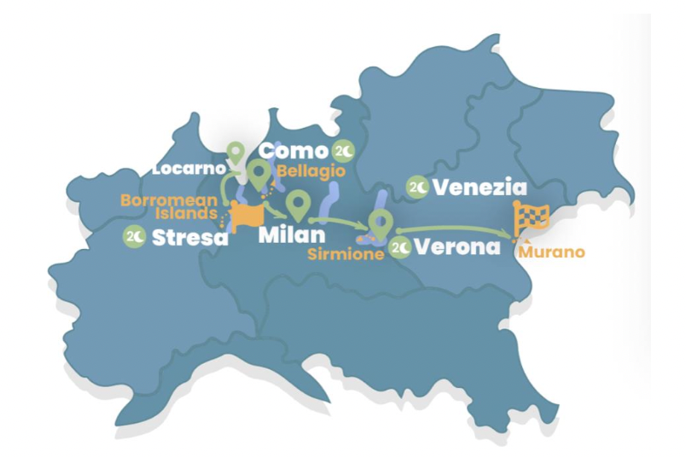
.

PHYSICAL LEVEL This trip can be enjoyed by just about anyone with a reasonable level of fitness. Average physical ability is required such as long walks of a few hours

You can check real time availability on our online PORTAL
MAX GROUP SIZE: 20 pax

WHAT’S INCLUDED

ACCOMODATION
8 nights in 4* hotel
- # 2 Stresa: Hotel Bristol, standard room city view
- # 2 Como: Hotel Terminus, classic room city view
- # 2 Verona: Hotel Indigo, standard room
- # 2 Venice: NH Collection Murano Villa, superior room

WORRY-FREE LUGGAGE
Thanks to our included porterage service at railway stations and/or our “luggage bus” (that delivers luggage from hotel to hotel), we make train travel stress-free.

GUIDE
Professional English speaking guide for the entire duration of the tour

TRANSPORT
Train transfers in First class
Vaporetto Pass 48H in Venice

MEAL
8 breakfasts
1 dinner

INCLUDED GROUP ACTIVITIES

STRESA: day tour of Isola Bella, Isola Madre, Isola dei Pescatori

CENTOVALLI TRAIN from Domodossola to Locarno

LOCARNO: walking tour

COMO: Lake of Como and Bellagio full day discovery

VERONA Walking tour // Sirmione & Lake Garda half day excursion.

VENICE Murano island walking tour with glass blowing visit // Highlights of Venice walking tour Rialto bridge, Gran Canal, St Mark Square, old tavern, local street food.

CARBON OFFSET
We'll offset all the carbon emissions of your trip! We support international environmental projects oriented to carbon offset (according to Gold Standard, Verra standard or CDM standard) and plants native tree species across Italy.

BRIEF DESCRIPTION
Explore the breathtaking lakes located in the North of Italy by characteristic Regional Trains. Enjoy your stay in charming 4-star luxury boutique hotels. A 9-days tour to discover authentic locations in Italy, from Lake Maggiore to lake Como, from Lake Garda to Venice.

INTRO - LONG DESCRIPTION
Enjoy breathtaking natural landscapes in the North of Italy. You will start from Stresa and visit the magnificent Isole Borromee on Lake Maggiore. Then, you will take the panorama train “Treno Panoramico Centovalli” to reach the beautiful Locarno, in Switzerland, and you will continue to Como. Enjoy a boat cruise to Bellagio and back. The next morning, on your way to Verona, you will hop off and take a tour to discover Milan’s best authentic places, along with a tram tour and a walking tour of the city center. Then, it’s time for Veneto: Verona and Lake Garda, and Venezia, the pearl of this region, await you. Take a walk between the beautiful canals and discover a unique artisanal experience in Murano, the homeland of the finest Italian glass. Relax in a charming hotel located right on the island.

ITINERARY
DAY 1 - STRESA
Upon arrival make your way to your hotel in Stresa. Take your time to settle and chill out in the relaxing environment of Lake Maggiore. Enjoy time at leisure, then at night take pleasure in a welcome dinner and meet your Tour Leader and group. Overnight at the hotel.

DAY 2 – STRESA
After breakfast board a ferry to explore the beauties of the lake and its island, the Isole Borromee. You will stop at Isola Bella and Isola Madre, famous for their baroque palaces and enchanting gardens. Let these tiny islands enchant you with their idyllic atmosphere.

DAY 3 – STRESA TO COMO via LOCARNO
Today depart with your group to discover the Centovalli railway. Its names (“one hundred valleys”) suggests that you will travel on one of the most spectacular European railways. This old route will take you across endless valleys and unforgettable landscapes while traveling from Domodossola to Locarno, where you will stop to enjoy this beautiful Swiss town on the lake. Depart then to Como by train, where your luggage will be waiting for you.

DAY 4 - COMO
Follow your guide and enjoy a walking tour of Como city center, then admire the splendid lakeside villas and gardens on a boat cruise across the lake. Reach by boat the famous village of Bellagio, the so-called “Pearl of the Lake”, and enjoy your time in this idyllic and relaxing place. Return to your hotel overnight.

DAY 5 – COMO TO VERONA via IN MILANO
After breakfast board a regional train that will take you to the lively city of Milan, the fashion capital of Italian style. Follow your guide across the city center and see the most famous attractions like the Duomo, a masterpiece of gothic architecture, as well as the Sforzesco Castle and the Fashion “Quadrilatero”. You’ll also have the chance to Travel on a historic “tram”, a real “Milanese” experience! In the afternoon take a train to Verona, reach your hotel where you will find your luggage.

DAY 6 – VERONA AND LAKE GARDA
Welcome to Verona! This morning explore the romantic city of Romeo and Juliet with the help of your tour leader. See its must-see attractions like the Arena, Piazza delle Erbe and the houses of Juliet and Romeo. In the afternoon depart for an excursion to discover lake Garda and its pearl: Sirimione, a medieval jewel-like town on the turquoise waters of the lake.

DAY 7 – FROM VERONA TO VENICE
This morning board your high-speed train heading to Venezia! Reach your hotel on the colorful Murano Island, where your luggage will be already waiting for you. In the afternoon follow your tour leader who will let you discover the ancient and precious glass-blowing art in a traditional “furnace”. Return to your hotel.

DAY 8 – VENICE
Today explore the floating City! Taking advantage of the Vaporetto Pass, move freely across the Historical center of Venice. Your guide will take you through narrow alleys, canals, and small bridges to discover the main attraction, witnessing the mighty power of the city across the centuries. You’ll see the Rialto Bridge, Piazza S. Marco with its Basilica, the Doge’s Palace, and the Bridge of Sighs, that leads to the prisons. Time at leisure to stroll on your own and buy local glass-made souvenirs.

DAY 9 – VENICE
After breakfast, our trip to the discovery of the Italian beauties comes to an end, hoping you always keep this unique experience in your heart. Feel free to book some extra nights in Venice or a private water taxi to the airport, port, or railway station.

